Homework 2: Huffman Coding and Vector Quantization

M10907324吳俊逸

Problem 1:  
Implementation of Huffman Coding

Participants can do simple implementation for alphabets with any probability vector as presented in the class.

Code：

Basic program structure：

Coding: Count the number of occurrences-->Probability-->Create codebook-->Replace text with codebook content

Decoding: count a few 1-->do all 1 processing-->get the index of each code-->replace the codebook content with text

clc;clear all;close all;

%%%%%%%%%%%%%%%%%%%%%%%%%%%%%%%%%%%%%%%%%%%%%%%%%%%%%%

% input English and space only %

%%%%%%%%%%%%%%%%%%%%%%%%%%%%%%%%%%%%%%%%%%%%%%%%%%%%%%

String_input ="a pig in my room";

%%%%%%%%%%%%%%%%%%%%%%%%%%%%%%%%%%%%%%%%%%%%%%%%%%%%%%

% coding start %

%%%%%%%%%%%%%%%%%%%%%%%%%%%%%%%%%%%%%%%%%%%%%%%%%%%%%%

eng_list=["a","b","c","d","e","f","g","h","i","j","k","l","m","n","o","p","q","r","s","t","u","v","w","x","y","z"," "];

count_val=0; % Word counter

count_zero=0; % Has 0 counter

count_coding=0; % Calculate the coding number counter

for i=1:1:27

n(2,i) = count(String_input, eng_list(1,i)); % Count the number of occurrences of each letter

count_val=count_val+n(2,i); % Count the total number of words

end

for i=1:1:27

n(3,i) = n(2,i) / count_val; % Calculate the probability of each letter

pa(1,i)=n(3,i);

end

[B,I]=sort(pa); % Sort B = Probability of occurrence I = Index after sorting

for i=1:1:27

if B(1,i)==0

count_zero=count_zero+1; % Count a few zeros

end

end

for i=1:1:27

if B(1,i)~=0

sort_num(1,i-count_zero)=eng_list(1,I(1,i)); % Sort after removing zero, index-->symbol

end

end

count_coding=27-count_zero;

k=0;

for i=1:1:count_coding

for j = 1:1:i-1

k=k*10+1;

end

if i ~= count_coding

coding_num1(1,i)=k*10;

else

coding_num1(1,i)=k;

end

k=0;

end

coding_Ans=String_input;

for j=1:1:count_coding

coding_Ans=strrep(coding_Ans,sort_num(1,j),int2str(coding_num1(1,j))); %Letters are converted into huffman coding

end

%%%%%%%%%%%%%%%%%%%%%%%%%%%%%%%%%%%%%%%%%%%%%%%%%%%%%%

% coding end %

%%%%%%%%%%%%%%%%%%%%%%%%%%%%%%%%%%%%%%%%%%%%%%%%%%%%%%

%%%%%%%%%%%%%%%%%%%%%%%%%%%%%%%%%%%%%%%%%%%%%%%%%%%%%%

% decoding_start %

%%%%%%%%%%%%%%%%%%%%%%%%%%%%%%%%%%%%%%%%%%%%%%%%%%%%%%

decoding_val=findstr(coding_Ans, '0'); %Found 0 address

decoding_sub(1,1)=decoding_val(1,1); %To know the address difference between two adjacent zeros, first fill in the prime minister, because the array does not have the zeroth item

a=0;b=0;

for i=2:1:length(decoding_val)

decoding_sub(1,i)=decoding_val(1,i)-decoding_val(1,i-1);

end

for i=2:1:length(decoding_val)

if decoding_sub(1,i) > (count_coding-1) %If the subtracted number is greater than the code length of the largest codebook content

a=a+1; %Know that this is the code length greater than the largest codebook content

index(1,a)=i; %Store its index item

sub_val(1,a)=fix(decoding_sub(1,i)/(count_coding-1)); %How many older

mod_val(1,a)=mod(decoding_sub(1,i),(count_coding-1)); %The last yard left

for k=1:1:sub_val(1,a)

add(1,k)=count_coding; %Combine the codes to be replaced (all ones)

end

if mod_val(1,a) ~= 0

add(1,sub_val(1,a)+1)=mod_val(1,a); %Combine the code to be replaced (the last code)

else

add(1,sub_val(1,a))=count_coding-1; %Combine the code to be replaced (the last code)

end

if a==1

decoding= [decoding_sub(1:index(1,1)-1) add(1,1:end) decoding_sub(index(1,1)+1:end)];%Put the first code to be replaced into

else

decoding= [decoding(1:index(1,a)-1+b) add(1,1:end) decoding(index(1,a)+1+b:end)];%Put other codes to be replaced into

end

b=b+length(add)-1; %Calculate the value of index to be inserted into the array

add=[];%Empty storage

end

end

decoding_Ans=decoding; %Copy the data to another array

for i=1:1:length(decoding)

decoding_Ans=strrep(decoding_Ans,decoding(1,i),sort_num(1,decoding(1,i)));%huffman coding into letters

end

%%%%%%%%%%%%%%%%%%%%%%%%%%%%%%%%%%%%%%%%%%%%%%%%%%%%%%

% decoding_end %

%%%%%%%%%%%%%%%%%%%%%%%%%%%%%%%%%%%%%%%%%%%%%%%%%%%%%%

%%%%%%%%%%%%%%%%%%%%%%%%%%%%%%%%%%%%%%%%%%%%%%%%%%%%%%

% Show the answer %

%%%%%%%%%%%%%%%%%%%%%%%%%%%%%%%%%%%%%%%%%%%%%%%%%%%%%%

String_input %English words to be encoded

coding_Ans %The result after Huffman encoding

decoding_Ans %The decoded text

example：

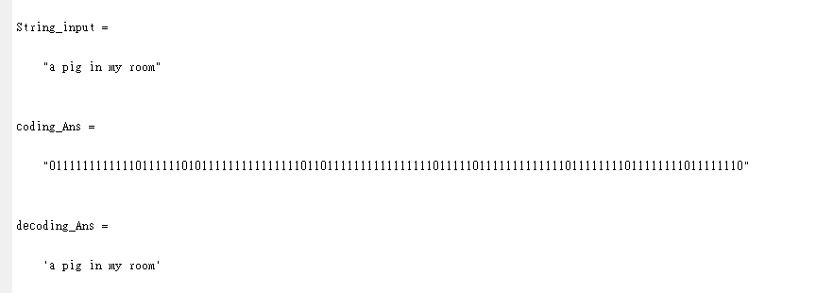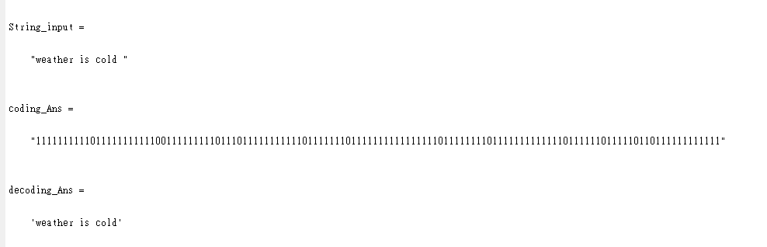

Problem 2:

Linde-Buzo-Gray (LBG) algorithm to perform Vector Quantization or any variants of LBG can also be considered for implementation.  
Participants can work on any image data-sets (even for a single image is fine) for training and implementation.

I prepare two methods

1. Compress the image directly

The codebook CB is obtained through the LBG () classification method. CB is composed of N k-dimensional codewords (N=256, k=16), i=1,2,3,...N-1.Compressed image: Suppose a grayscale image T of size T is divided into image blocks B of size. Then find the index table Gi through optimization.Image decompression: A compressed image can be generated according to the index table and CW.

Code：

clc;clear all;close all;

%%

tic;

a=4;

b=a*a;

input=imread('lena.bmp');

I=double(imread('lena.bmp'));

B=im2col(I,[a,a],'distinct');% Decompose the image into a 16*(128*128) matrix

[m,n]=size(B);

N=256;

CB=zeros(m,N);

CW=zeros(1,n);

rng(999);

CB_cnt=randperm(n);

CB=B(:,CB_cnt(1:N));

for x=1:10%10 iterations

for y=1:n%training

p=B(1:b,y)*ones(1,N);

[~,yy]=min(sum((p-CB).^2));

CW(y)=yy;

end

for z=1:N%Select

v=find(CW==z);

for k=1:m

nv=sum(B(k,v))/numel(v);

CB(k,z)=nv;

end

end

end

toc

DE=zeros(m,n);

for i=1:n

DE(:,i)=CB(:,CW(i));

end

img_4=col2im(DE,[a,a],[512,512],'distinct');

%%

tic;

a=8;

b=a*a;

input=imread('lena.bmp');

I=double(imread('lena.bmp'));

B=im2col(I,[a,a],'distinct');% Decompose the image into a 64*(64*64) matrix

[m,n]=size(B);

N=256;

CB=zeros(m,N);

CW=zeros(1,n);

rng(999);

CB_cnt=randperm(n);

CB=B(:,CB_cnt(1:N));

for x=1:10%10 iterations

for y=1:n%training

p=B(1:b,y)*ones(1,N);

[~,yy]=min(sum((p-CB).^2));

CW(y)=yy;

end

for z=1:N%Select

v=find(CW==z);

for k=1:m

nv=sum(B(k,v))/numel(v);

CB(k,z)=nv;

end

end

end

toc

DE=zeros(m,n);

for i=1:n

DE(:,i)=CB(:,CW(i));

end

img_8=col2im(DE,[a,a],[512,512],'distinct');

%%

tic;

a=16;

b=a*a;

input=imread('lena.bmp');

I=double(imread('lena.bmp'));

B=im2col(I,[a,a],'distinct');% Decompose the image into a 256*(32*32) matrix

[m,n]=size(B);

N=256;

CB=zeros(m,N);

CW=zeros(1,n);

rng(999);

CB_cnt=randperm(n);

CB=B(:,CB_cnt(1:N));

for x=1:10%10 iterations

for y=1:n%training

p=B(1:b,y)*ones(1,N);

[~,yy]=min(sum((p-CB).^2));

CW(y)=yy;

end

for z=1:N%Select

v=find(CW==z);

for k=1:m

nv=sum(B(k,v))/numel(v);

CB(k,z)=nv;

end

end

end

toc

DE=zeros(m,n);

for i=1:n

DE(:,i)=CB(:,CW(i));

end

img_16=col2im(DE,[a,a],[512,512],'distinct');

%%

subplot(221);

imshow(input);title('Input Image');

subplot(222);

imshow(uint8(img_4));title('VQ-16*(128*128) matrix');

subplot(223);

imshow(uint8(img_8));title('VQ-64*(64*64) matrix');

subplot(224);

imshow(uint8(img_16));title('VQ-256*(32*32) matrix');

Results of the code：

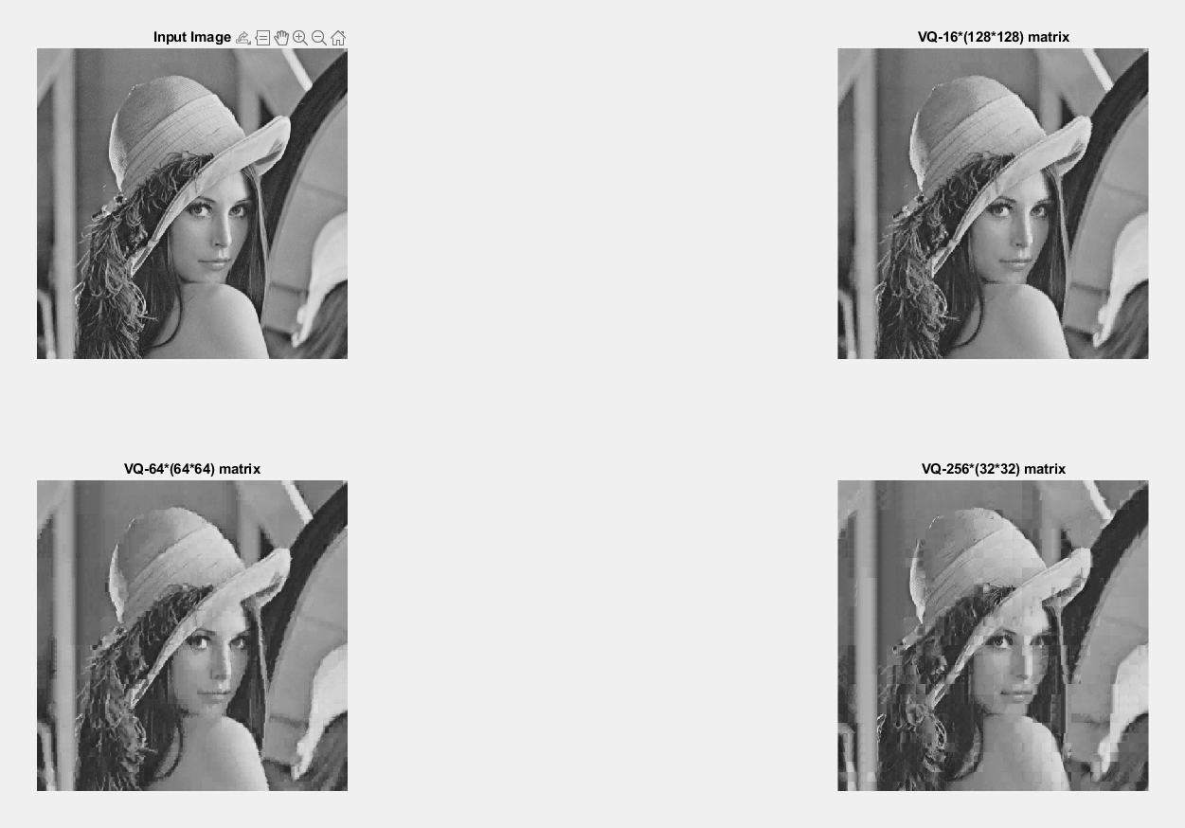

Code1🡪Codebook training, take codebook=256 as an example：

Basic program structure：

-->Take the two adjacent points in the photo as a group and send it to the codebook to evaluate the distance

--> rank the results after evaluation and take the first index

--> add this group of data to code_avg, and calculate the number of times in code_time Medium

-->Calculate the average of all points closer to the node

-->Replace the result in the original codebook

-->The preset number of training is ten times, which means that the above actions are repeated ten times

-->The final codebook Save in txt

-->END

clc;clear all;close all;

A2=[27 107 13 39 133 194 164 39 167 148 223 108 112 70 113 180 169 192 203 104 116 240 218 37 160 23 89 4 213 127 100 117 218 64 0 65 156 189 122 53 100 165 153 33 23 226 116 74 99 196 170 48 54 17 168 162 119 81 140 86 44 208 108 102 166 222 177 175 84 174 248 96 154 132 233 239 163 80 172 157 55 221 106 95 91 63 12 137 26 164 85 52 136 218 158 7 90 203 88 163 160 223 140 236 144 231 198 93 24 15 80 15 17 191 90 228 64 18 6 54 72 116 155 199 93 250 237 226 ;

91 27 13 37 127 117 164 165 47 148 221 103 129 71 192 180 250 119 194 217 181 163 102 159 28 228 226 118 125 58 52 160 121 244 97 91 149 226 62 106 163 226 144 225 114 240 78 150 137 97 97 0 166 194 97 30 76 7 3 201 205 222 163 50 66 64 196 132 158 59 44 165 40 26 90 25 1 252 230 80 81 149 30 236 144 82 60 86 109 173 208 198 240 142 152 107 77 193 202 166 238 77 30 14 155 201 90 188 242 160 199 22 230 45 114 79 145 15 246 43 188 36 121 88 85 215 78 215

]; %Codebook after taking random random numbers

for i=1:1:10

code_avg=[0 0 0 0 0 0 0 0 0 0 0 0 0 0 0 0 0 0 0 0 0 0 0 0 0 0 0 0 0 0 0 0 0 0 0 0 0 0 0 0 0 0 0 0 0 0 0 0 0 0 0 0 0 0 0 0 0 0 0 0 0 0 0 0 0 0 0 0 0 0 0 0 0 0 0 0 0 0 0 0 0 0 0 0 0 0 0 0 0 0 0 0 0 0 0 0 0 0 0 0 0 0 0 0 0 0 0 0 0 0 0 0 0 0 0 0 0 0 0 0 0 0 0 0 0 0 0 0 ;

0 0 0 0 0 0 0 0 0 0 0 0 0 0 0 0 0 0 0 0 0 0 0 0 0 0 0 0 0 0 0 0 0 0 0 0 0 0 0 0 0 0 0 0 0 0 0 0 0 0 0 0 0 0 0 0 0 0 0 0 0 0 0 0 0 0 0 0 0 0 0 0 0 0 0 0 0 0 0 0 0 0 0 0 0 0 0 0 0 0 0 0 0 0 0 0 0 0 0 0 0 0 0 0 0 0 0 0 0 0 0 0 0 0 0 0 0 0 0 0 0 0 0 0 0 0 0 0];

code_time=[0 0 0 0 0 0 0 0 0 0 0 0 0 0 0 0 0 0 0 0 0 0 0 0 0 0 0 0 0 0 0 0 0 0 0 0 0 0 0 0 0 0 0 0 0 0 0 0 0 0 0 0 0 0 0 0 0 0 0 0 0 0 0 0 0 0 0 0 0 0 0 0 0 0 0 0 0 0 0 0 0 0 0 0 0 0 0 0 0 0 0 0 0 0 0 0 0 0 0 0 0 0 0 0 0 0 0 0 0 0 0 0 0 0 0 0 0 0 0 0 0 0 0 0 0 0 0 0 ;

0 0 0 0 0 0 0 0 0 0 0 0 0 0 0 0 0 0 0 0 0 0 0 0 0 0 0 0 0 0 0 0 0 0 0 0 0 0 0 0 0 0 0 0 0 0 0 0 0 0 0 0 0 0 0 0 0 0 0 0 0 0 0 0 0 0 0 0 0 0 0 0 0 0 0 0 0 0 0 0 0 0 0 0 0 0 0 0 0 0 0 0 0 0 0 0 0 0 0 0 0 0 0 0 0 0 0 0 0 0 0 0 0 0 0 0 0 0 0 0 0 0 0 0 0 0 0 0];

data=double(imread("./imgdata/cameraman.tif"));

nx=256;

ny=256;

for i = 1:1:nx

for j=1:2:ny%Throw the two points in the picture as a group into the codebook to evaluate the distance

for k = 1:1:16

sub(1,k)=(data(i,j)-A2(1,k))^2+(data(i,j+1)-A2(2,k))^2;%Calculate the distance between each point and the node

end

[B,I]=sort(sub);%"B" is the look after sorting, "I" is the index of the original position before sorting

code_avg(1,I(1,1))=code_avg(1,I(1,1))+data(i,j);%Add the points closest to the node into the variable code_avg

code_avg(2,I(1,1))=code_avg(2,I(1,1))+data(i,j+1);

code_time(1,I(1,1))=code_time(1,I(1,1))+1;%Calculate the accumulation times in code_time

end

end

for j=1:1:2

for i = 1:1:128

code_avg(j,i)=code_avg(j,i)/code_time(1,i);%Average the points near the node

if(uint8(code_avg(j,i))~=0)

A2(j,i)=uint8(code_avg(j,i));%Write the changed data into the codebook variable

end

end

end

end

fid=fopen(['./','codebook_256.txt'],'w');%Write file path

[r,c]=size(A2);% Get the number of rows and columns of the matrix

for i=1:r

for j=1:c

fprintf(fid,'%f\t',uint8(A2(i,j)));%Write data to txt file

end

if(i==1)

fprintf(fid,';\n');%Matlab notation for conversion to 2-dimensional matrix reduction

else

fprintf(fid,'\n');

end

end

fclose(fid);

Code2🡪Use self-built codebook to apply to VQ compression：

clc;clear all;close all;

ccc=512;

input=imread('lena.bmp');

A_16=[27 70 110 113 149 153 169 180 183 188 192 215 223 228 240 248];

aaa_16=imread('lena.bmp');

for i=1:1:ccc

for j = 1:1:ccc

aaa_16(i,j);

for k=1:1:16

if(aaa_16(i,j)>A_16(1,k))

sub_16(1,k)=aaa_16(i,j)-A_16(1,k);%Calculate the distance between each point and the node

else

sub_16(1,k)=A_16(1,k)-aaa_16(i,j);%Calculate the distance between each point and the node

end

end

[B,I]=sort(sub_16);%"B" is the look after sorting, "I" is the index of the original position before sorting

aaa_16(i,j)=A_16(I(1,1));

end

end

A_64=[5 12 13 19 20 23 24 27 39 41 46 47 51 53 55 59 61 64 65 72 74 76 81 82 91 92 99 106 107 110 111 114 115 118 121 136 146 148 149 152 155 156 157 160 163 169 173 174 177 179 182 183 185 187 205 210 215 222 224 228 232 242 246 254];

aaa_64=imread('lena.bmp');

for i=1:1:ccc

for j = 1:1:ccc

aaa_64(i,j);

for k=1:1:64

if(aaa_64(i,j)>A_64(1,k))

sub_64(1,k)=aaa_64(i,j)-A_64(1,k);%Calculate the distance between each point and the node

else

sub_64(1,k)=A_64(1,k)-aaa_64(i,j);%Calculate the distance between each point and the node

end

end

[B,I]=sort(sub_64);%"B" is the look after sorting, "I" is the index of the original position before sorting

aaa_64(i,j)=A_64(I(1,1));

end

end

A_256=[27 107 13 39 133 194 164 39 167 148 223 108 112 70 113 180 169 192 203 104 116 240 218 37 160 23 89 4 213 127 100 117 218 64 0 65 156 189 122 53 100 165 153 33 23 226 116 74 99 196 170 48 54 17 168 162 119 81 140 86 44 208 108 102 166 222 177 175 84 174 248 96 154 132 233 239 163 80 172 157 55 221 106 95 91 63 12 137 26 164 85 52 136 218 158 7 90 203 88 163 160 223 140 236 144 231 198 93 24 15 80 15 17 191 90 228 64 18 6 54 72 116 155 199 93 250 237 226 ;

91 27 13 37 127 117 164 165 47 148 221 103 129 71 192 180 250 119 194 217 181 163 102 159 28 228 226 118 125 58 52 160 121 244 97 91 149 226 62 106 163 226 144 225 114 240 78 150 137 97 97 0 166 194 97 30 76 7 3 201 205 222 163 50 66 64 196 132 158 59 44 165 40 26 90 25 1 252 230 80 81 149 30 236 144 82 60 86 109 173 208 198 240 142 152 107 77 193 202 166 238 77 30 14 155 201 90 188 242 160 199 22 230 45 114 79 145 15 246 43 188 36 121 88 85 215 78 215 ];

aaa_256 = imread('lena.bmp');

nx=256;

ny=256;

for i = 1:1:nx

for j=1:2:ny%Throw the two points in the picture as a group into the codebook to evaluate the distance

for k = 1:1:16

sub(1,k)=(aaa_256(i,j)-A_256(1,k))^2+(aaa_256(i,j+1)-A_256(2,k))^2;%Calculate the distance between each point and the node

end

[B,I]=sort(sub);%"B" is the look after sorting, "I" is the index of the original position before sorting

aaa_256(i,j)=A_256(1,I(1,1));

aaa_256(i,j+1)=A_256(2,I(1,1));

end

end

%%

subplot(221);

imshow(input);title('Input Image');

subplot(222);

imshow(uint8(aaa_16));title('VQ-Use 16 codebooks');

subplot(223);

imshow(uint8(aaa_64));title('VQ-Use 64 codebooks');

subplot(224);

imshow(uint8(aaa_256));title('VQ-Use 256 codebooks');

Results of the code：

